Locate Packing Slips

Purpose:
- This Job Aid illustrates how to locate packing slips.
Steps:
- Enter your credentials, i.e. Email and Password. Then select the SUBMIT button.
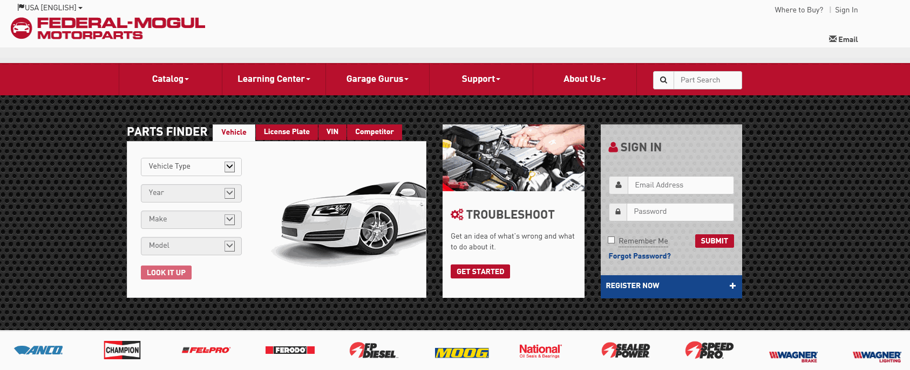
- Select My Account.
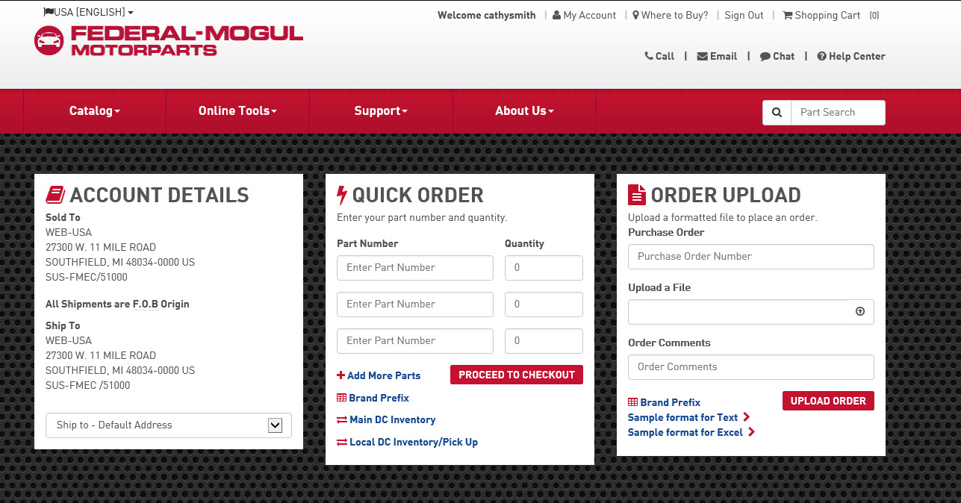

- In the MY ACCOUNT menu, select Order history.
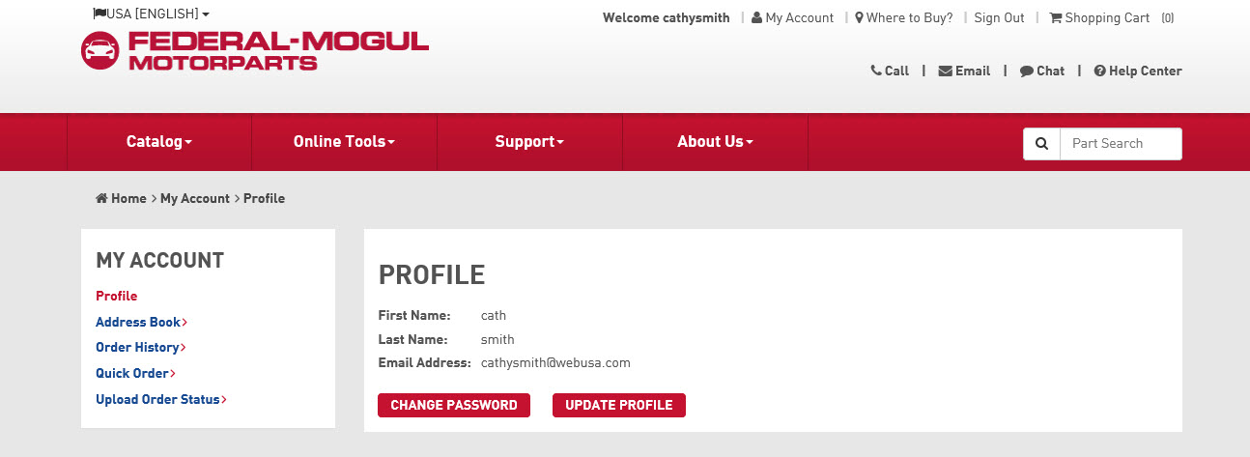

- Under the Packing Slip # column you will see the available Packing Slip # for each order. To view the packing slip details, select the Packing Slip #.
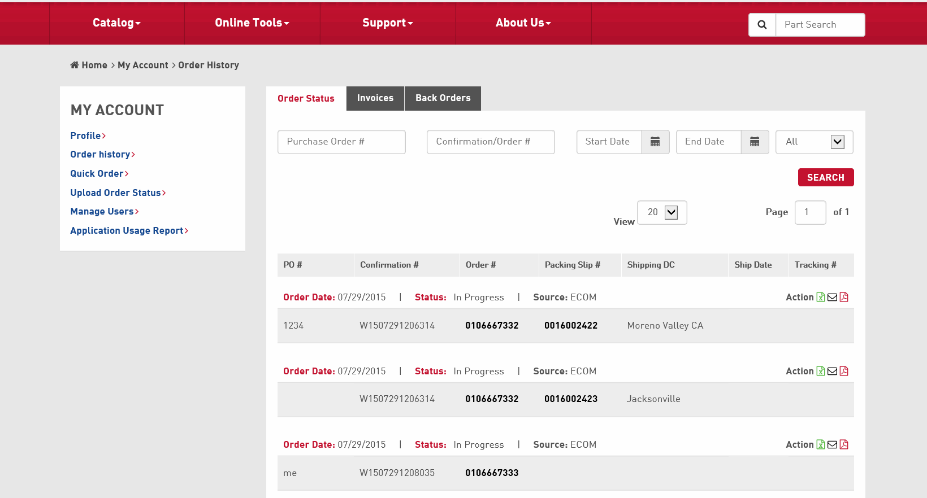
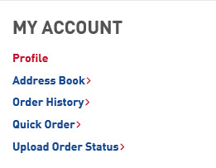
- The ORDER DETAILS Screen will be visible. You can view the SHIPPING DETAILS, SHIPPING FROM location, and Item Details.
